Video 29 – deploy to firebase

<https://www.youtube.com/watch?v=e-aAAbY0miY>

Need to have node installed

The goto Firebase and install firebase tools globally

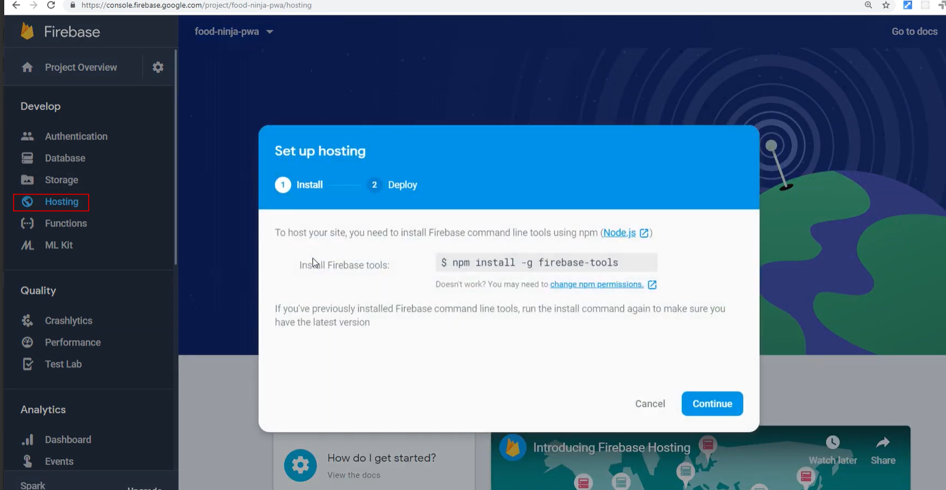

Then continue

And log into the service via the command line

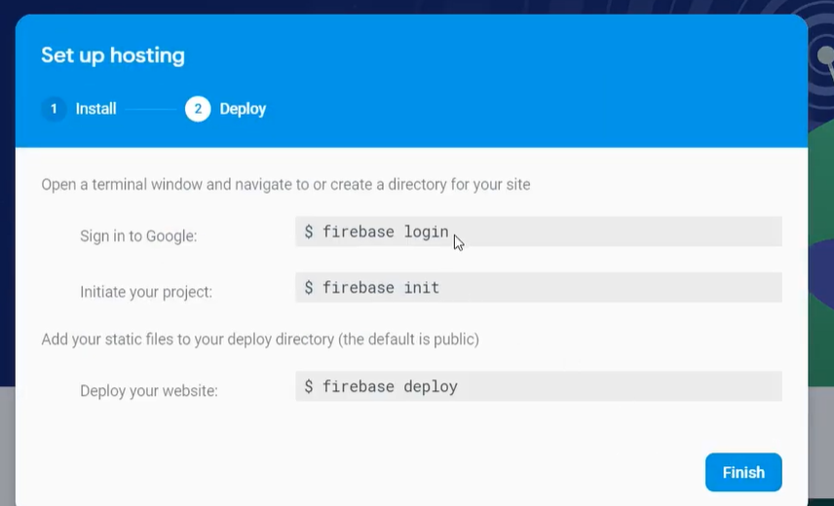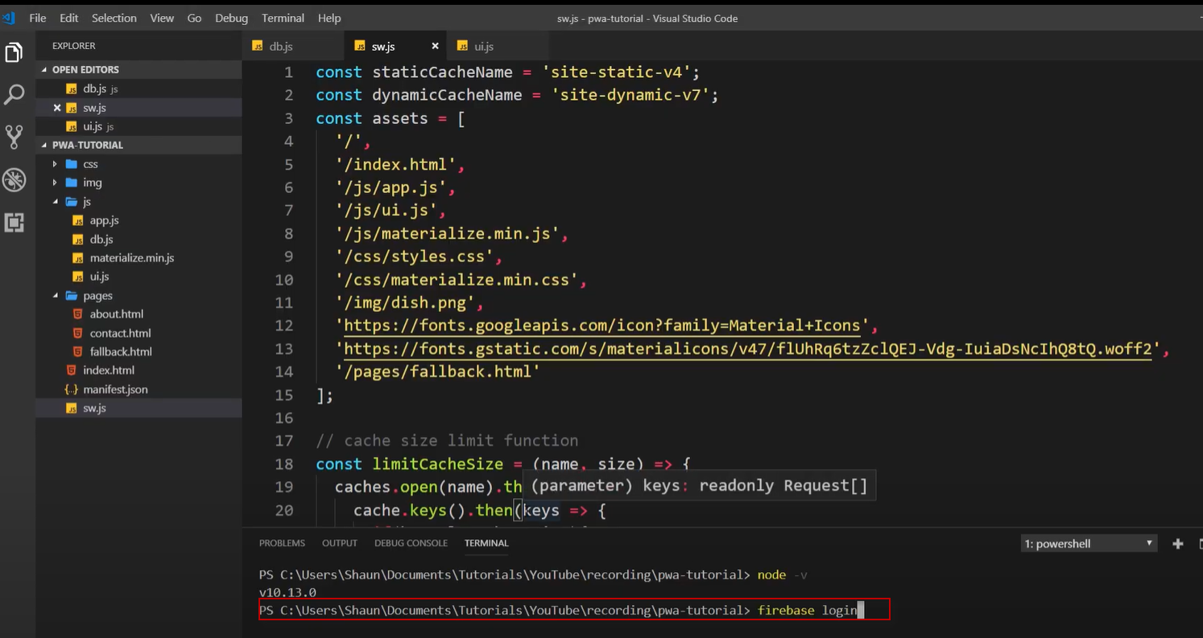

Then initiate a new project inside the app

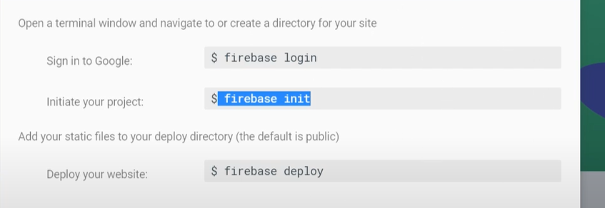

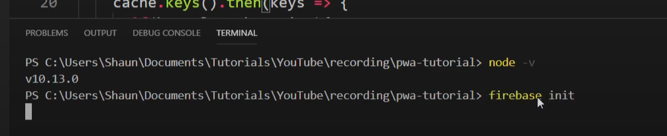

Here we just need hosting (with space bar)

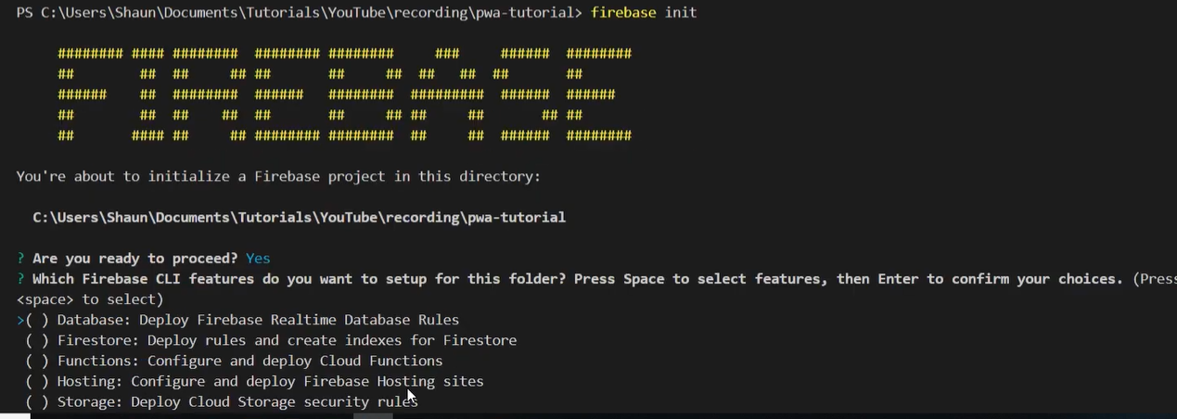

Asking to link to a backend project, we have already done that on firebase so no need to create , just pick from list

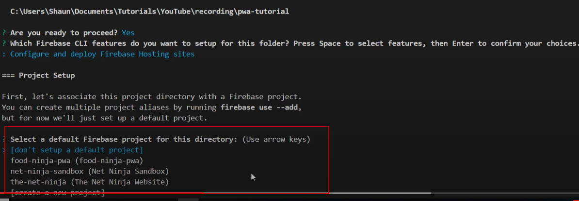

Deploy to default directory(pubic)

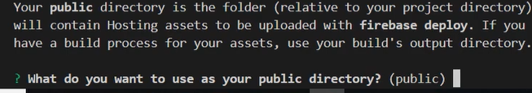

We are not deploying as single page app so not here

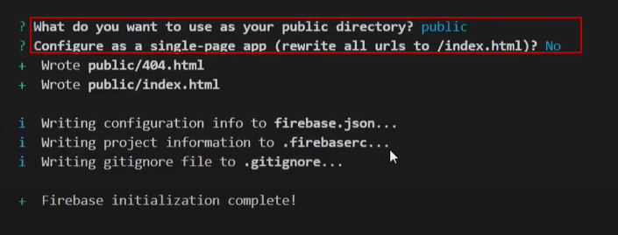

Fire base created the public folder and the index.html and 404.html, do not need this index.html file so delete it.

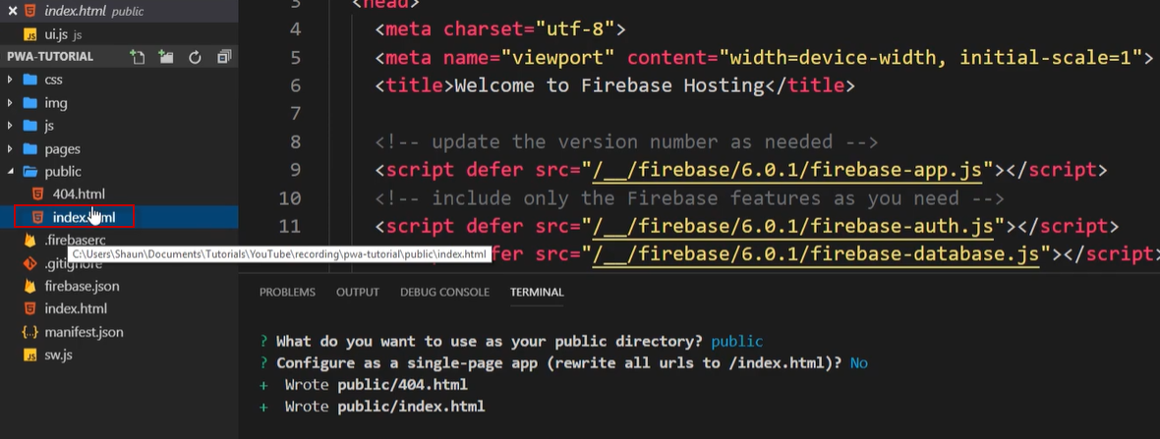

Then move the other files we have made into the public folder

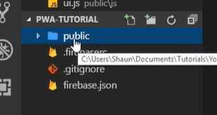

Then run the firebase deploy command 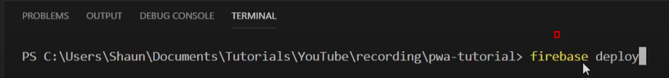

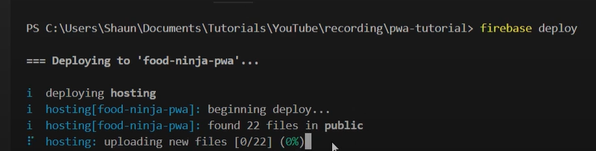

We then get a hosting URL

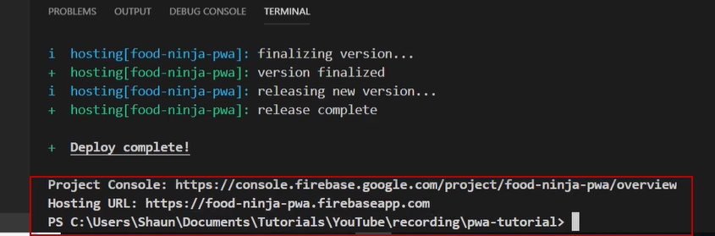

Also can now see it in the hosting section on firebase

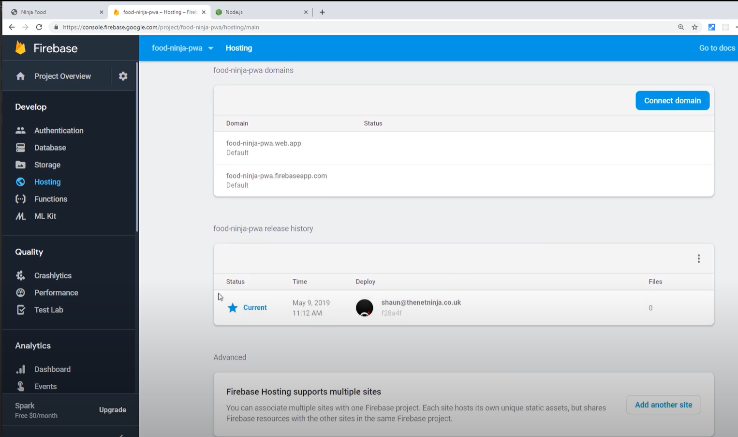

My App

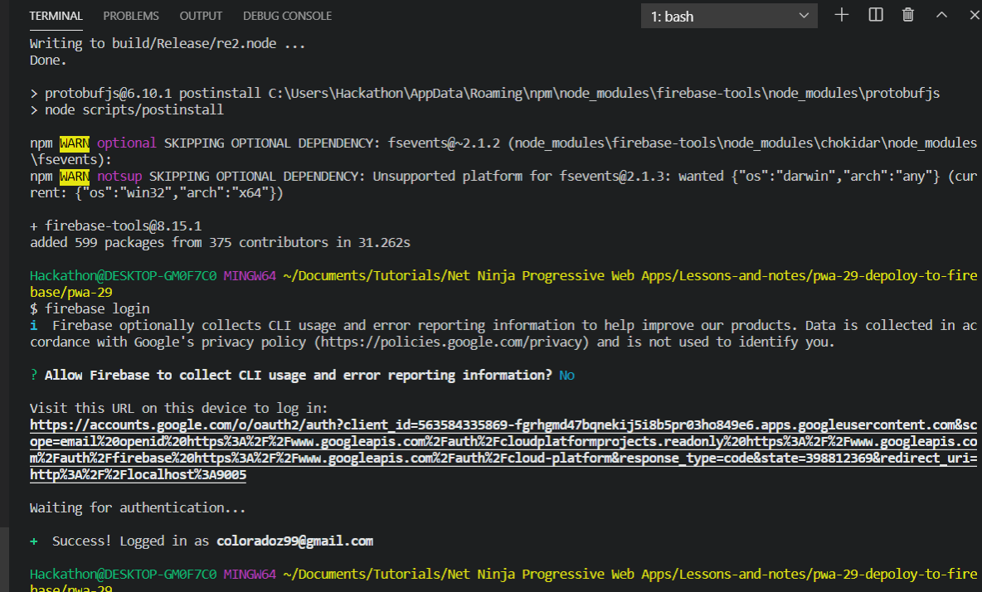

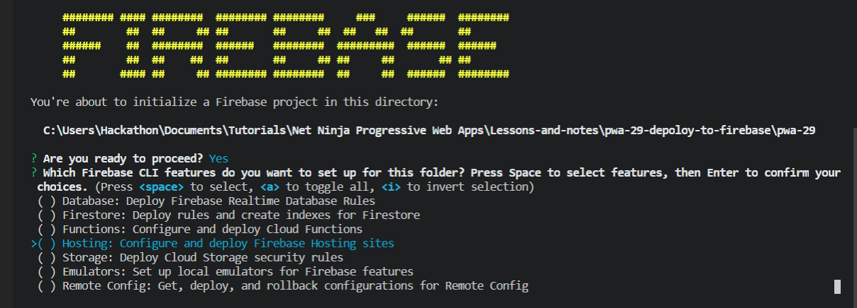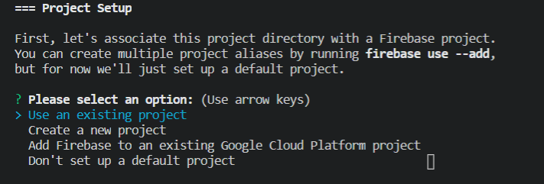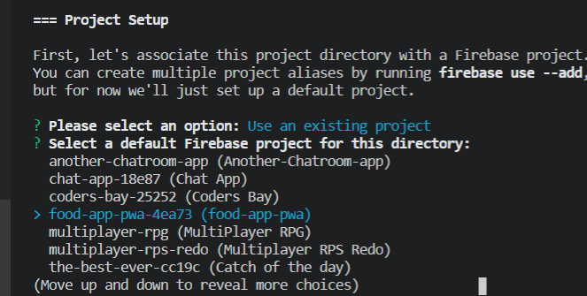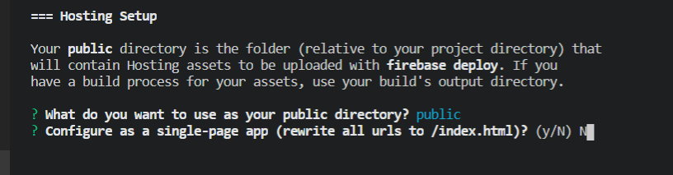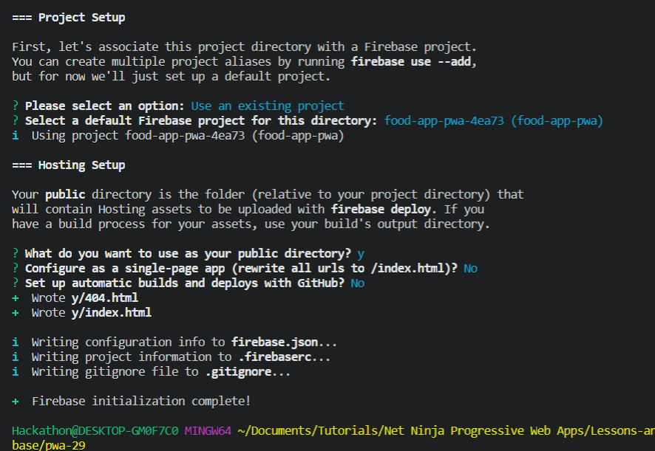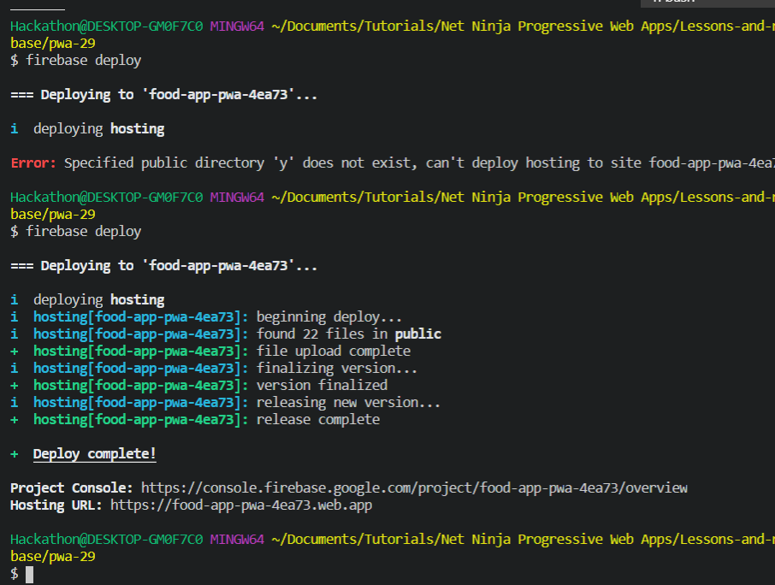

Project Console: <https://console.firebase.google.com/project/food-app-pwa-4ea73/overview>

Hosting URL: <https://food-app-pwa-4ea73.web.app>

